Superintendent  Ken Kenworthy  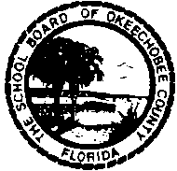 | School District of Okeechobee County  863-462-5000 700 S. W. Second Avenue Fax 863-462-5151  Okeechobee, Florida 34974 | Board Chairperson:  Malissa Morgan  Board Vice Chairperson:  Jill Holcomb  Board Members:  Joe Arnold  Dixie Ball  India Riedel

The Okeechobee County School Board will conduct a public hearing on participation in the Indian Education Formula Grant Monday, May 2, 2016 at 10:00 am in Room 306 at 700 SW 2nd Avenue. The purpose of the meeting is to explain the goals of the 2016-17 grant and activities associated with the Title VII program. Any questions or comments please contact Toni Wiersma at 462-5000, Ext. 258.

