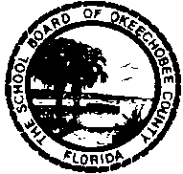 |  | School Board of Okeechobee County  Agenda for Workshop  September 8, 2016  4:00 p.m. | Chairperson  Malissa Morgan  Vice Chairperson  Jill Holcomb  Members  Joe Arnold  Dixie Ball  India Riedel

Call to Order

Information/Discussion Items

Subject: Possibility of Special Facilities Construction

The workshop will be held at and include a tour of Okeechobee High School, 2800 Highway 441 North, Okeechobee.
Information will be presented at the workshop and is available upon request
in the Superintendent’s office.

Vision
Achieving Excellence:
Putting Students First
Mission
To prepare all students to be college and career ready and function as productive citizens.
Core Values
Perseverance
Respect
Integrity
Dependability
Ethics

The next regular meeting and Public Hearing of the School Board is Thursday, September 8, 2016, at 6:00 p.m.

Persons are advised that if they decide to appeal any decisions made at this meeting, they will need a record of the proceedings, and for such purpose, they may need to ensure that a verbatim record of the proceedings is made, which record includes the testimony and evidence upon which the appeal is to be made.

