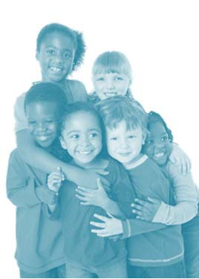
What does the McKinney- Vento Act require schools to do for children who have lost housing?

Florida’s
McKinney-Vento

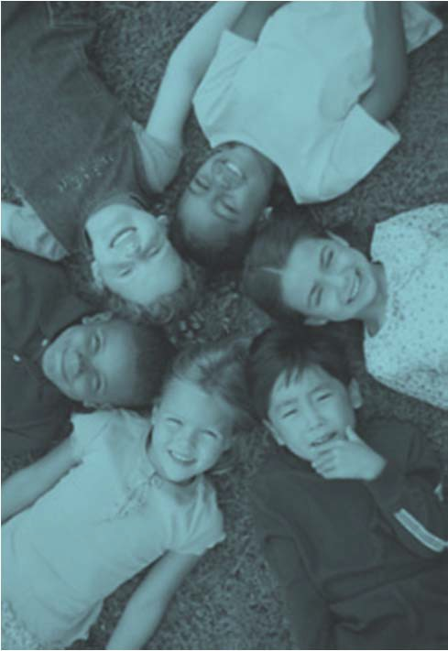
Program

Schools must keep children in the school of origin (the school the child or youth attended when permanently housed or where last enrolled) to the extent feasible, except where contrary to the wishes of the parent or guardian.

Children or youth’s right to attend their school of origin extends throughout the duration of homelessness.

Schools must remove any barriers that contribute to exclusion or enrollment delay. This means schools are required to enroll immediately students experiencing homelessness, and then follow up to retrieve missing information, school records, immunization records, etc.

Each school must post the contact information of the district’s Homeless Education Liaison.

Each school must post public notice of educational rights of children and youth experiencing homelessness.

Schools must ensure enrollment with full and equal opportunity for students to succeed in school, including participation in such school district programs as Title I, exceptional student education, vocational and technical, Head Start, Even Start, preschool, etc.

Local Area Contacts:

Bea Rodriguez, 863-462-5000, ext.1066

Alexandra G. Navarrete, 863-462-5000, ext.1047

Interim State Coordinator:

Courtney Walker
Florida Department of Education Bureau of Federal Educational Programs Homeless Education Program Tallahassee, Florida 32399‐0400
850‐245‐9946

Program Website
http://www.fldoe.org/policy/federal-edu-programs/title-x-homeless-edu-program-hep.stml

Serving Students Who

Lost Housing

Bridging the Gap between

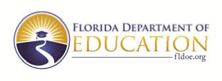
Living in Transition and School

Every Child Has the Right to an Education

If you lost your housing due to economic hardship, natural disaster, or other similar reason, and are living temporarily with friends or relatives, or in a shelter, motel, vehicle, or campground; or on the street; in an abandoned building, then you are eligible to receive services provided under the McKinney‐Vento Act.

Your children have the right to:

➢ Go to their school of origin (the school the child or youth attended when permanently housed or where last enrolled) or zoned school.
➢ Continue in the school they last attended before they lost their housing, if that is the parent/guardian’s choice, and it is feasible and in the child’s best interest, or the school for which they are zoned due to their current living situation.
➢ Enroll and attend classes immediately while the school arranges for the transfer of school and immunization records and any other documents required for enrollment.
➢ Enroll and attend classes in the school where they are seeking enrollment (school of origin or zoned school) even while the school and the parent/guardian are seeking to resolve a dispute over which school is in the best interest of the child – Note: This does not mean any school in the district, only the school of origin or zoned school.
➢ Receive transportation to the school they last attended before they lost their housing (if a parent/guardian requests such transportation); however, if the student lives within two miles of the school, then transportation is not guaranteed.
➢ Participate in any school programs and receive any school services for which they qualify.

Questions for Parents to Ask at School

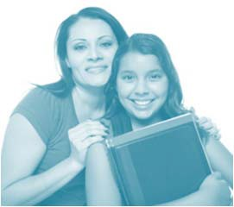
Children can be encouraged by your interest in their day at school, their homework, and the papers they bring from school.

They also benefit when you take time to ask questions about school and visit their school.

Here are some questions for you to ask at your child’s school:

➢ Who is the local liaison for homeless education?
➢ What transportation is available for my child to stay in the same school?
➢ If we have to change schools, who can help us quickly transfer records?
➢ Is there a preschool program?
➢ Is there a summer school program?
➢ What tutoring services are available for my child?
➢ If I think my child needs special education services, what do I need to do to get them evaluated?
➢ If my child has a certain talent, are there special classes to benefit that talent?
➢ What extracurricular activities are offered by this school? How can my child participate?
➢ How can my child receive free meals at school?
➢ Where are school supplies available?
➢ How will my child be able to go on educational field trips if we are unable to pay?
Free Lunch and Breakfast Program
Public school children benefit from federal school nutrition programs that provide nutritious meals. Free breakfast and lunch are
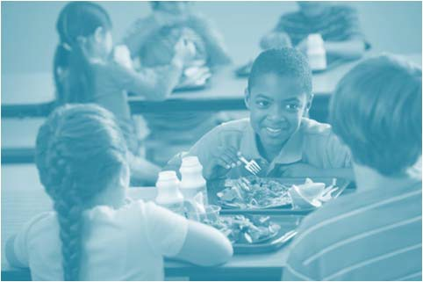

available to homeless children in public schools that offer them, if they qualify for McKinney‐ Vento services.

Special Education Services

Florida children between ages 3 and 22, who are eligible for Exceptional Student Education (ESE) Programs, may receive a variety of services provided through the public school system. If a homeless child has an identified disability, he or she may be eligible for special education services.

Parents who believe their child may qualify for special education should contact either the ESE or Student Services Department in their school district for additional information about programs for students with disabilities.

