2015
Skyward Principal Guide
HOW TO GUIDES
BRANHAM, MICHELLE
Contents
Grade Distribution Report 2
Monitor Grades by Teacher Report (Last Assignment Scored) 4
Number of Failing Grade Marks by Teacher 4
How to Create a Scheduled Task in Skyward 5
Gradebook Missing Assignments Report 8

Grade Distribution Report

- Open Skyward Student Management
- Select Office from the tabs at the top of the screen
- Select Reports under the Grading section
- Select Grade Analysis – GO
- Clone the Grade Distribution Report created by Michelle Branham, or you can add/edit your own report
- 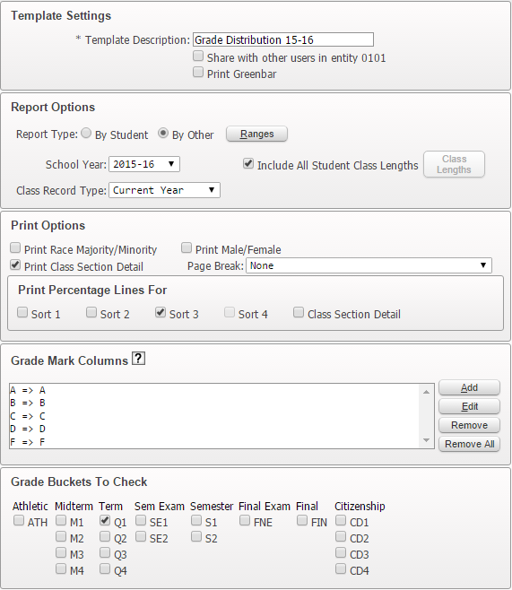
- To only view selected classes you can click on ranges to insert the course codes of the classes you would like to see the grade distribution on. 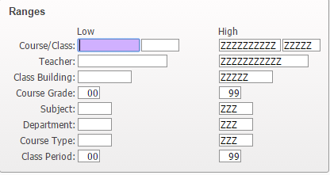
- Put in the Low and High value which will be the course code. Make sure to include those qualifiers to pull all of the courses.
- Click OK.
- You can sort by multiple items. To see how your report is sorted click on the Sort By button on the right side.
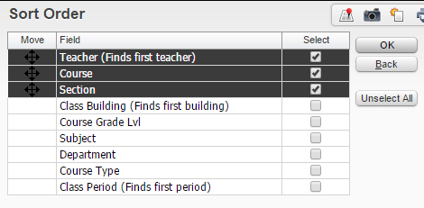
- Click OK.
- Select Save and Print to view your report.

Monitor Grades by Teacher Report (Last Assignment Scored)
- Open Skyward Student Management
- Click on Educator Access Plus on the top row.
- Select Monitor by Teacher under Teacher Tracking
- Scroll over to one of the last columns to find Last Scored Asn Date. 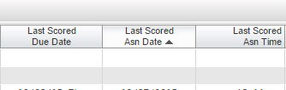
- This gives you the date that the teacher last scored an assignment
- You can click on the title of that column to sort the column.
- Click on the Excel icon on the upper right side to import into Excel. 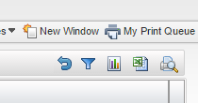
- Select Export to Excel then click on Export.
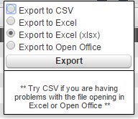
- Your report will download for you to sort, edit and review within Excel.

Number of Failing Grade Marks by Teacher
- Open Skyward Student Management
- Click on Educator Access Plus on the top row.
- Select Monitor by Teacher under Teacher Tracking
- Click on the Views dropdown menu and select Current Grades
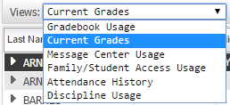
- You can create a filter to only display the classes that have a gradebook. To do that click on Filters.
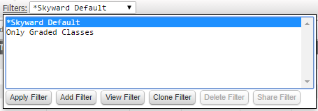
- Select Add Filter
- Name the filter.
- On the filter Has Gradebook? Select Yes instead of both.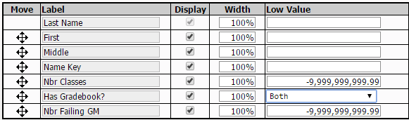
- Click Save and Apply Filter

How to Create a Scheduled Task in Skyward
Important: You have to begin by creating running a report from Data Mining or any other report tab.

- Click on My Print Queue in the upper right corner.
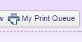

- It will open and you will see this list on the right side. Click on Tasks.
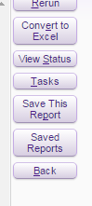

- Click on Schedule This.
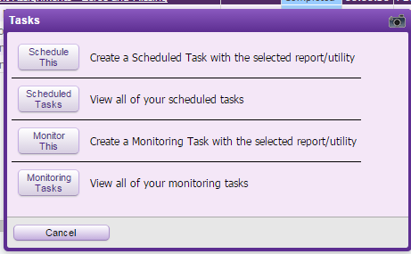

- You can fill in the task information for the start date of the task. Change the time to either 3:00 AM or 4:00 AM. We have a lot of other stuff that runs from 1:00-2:00 AM already. Set the end date for the end of the school year.
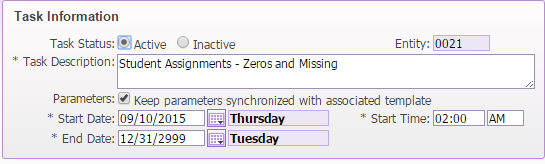
- Fill in the days and month that you want this report to run. Do you really want it to run every single day, or is once per week enough? 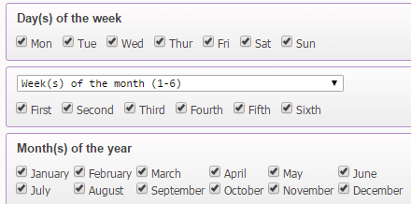

- THE BEST PART! Put in your email address (or others) in the Email Results to section. Don’t put in an Export File Path. 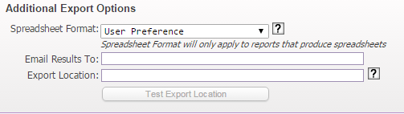

- If you would also like for this report to show under your notification widget or someone else’s notification widget in Skyward you can click this box and then add their name. 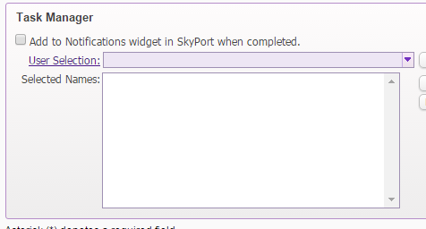

- Click Save and it’s now scheduled to run at the times that you have requested.
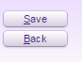

Gradebook Missing Assignments Report

- Click on Student Management.
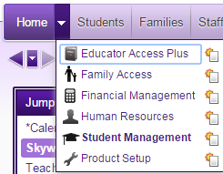

- Go to Educator Access Plus.
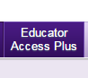

- Click on Reports under Gradebook.

- Click on Student Assignments.
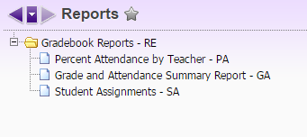

- Click Add.

- Add a title. You can create a report for each teacher, or you can run this for the entire school.
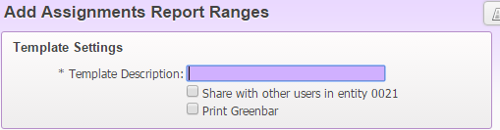

- Right now you will keep it By Range. You can select By Grading Period then it will change to Use Current.

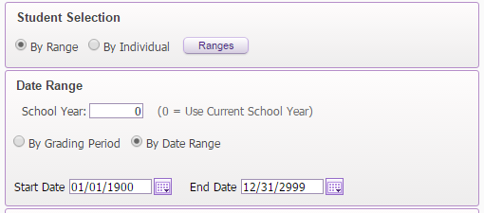

- Click on Missing. This will only print if the teacher has marked missing in their gradebook. It will not print if they are putting in zeros as the final grade of an assignment. I checked one of the other boxes for No Count.

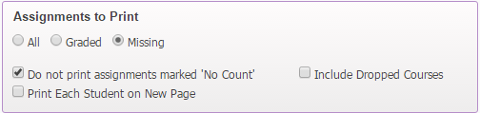

- You can play around with this piece to see what you want to see on the report.
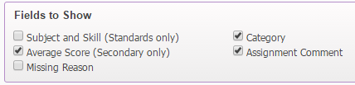
- Click Save and Print.
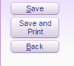
- Your report will process.
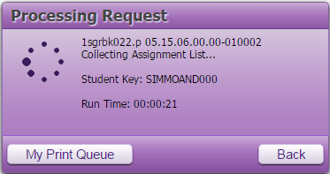

- Select View Report
