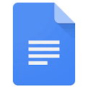Google Docs cheat Sheet

Tools menu highlights

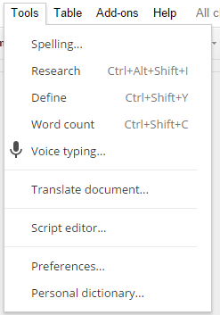

**Research** – Search Google without leaving the document. When you click on Research a new panel opens on the left. You can search for images (pictures) just like Google!

**Voice Typing** – Click on Voice typing… for it to type what you say. You will then click “Allow” before it works!

voice Typing

Click the Microphone > Click Allow > Microphone Turns Red > Talk Slowly > Click the Microphone to STOP

