Step 1: Open your District Gmail Account.
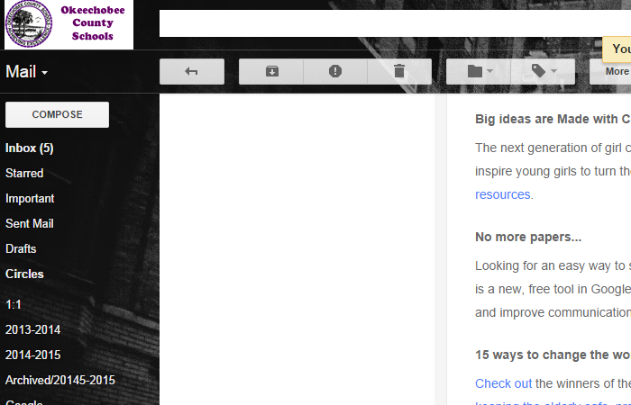
Step 2: Open the Setting Menu and select Settings.
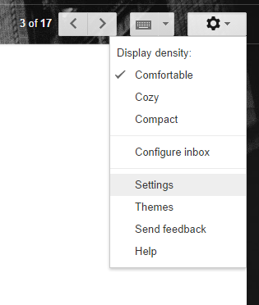
Step 3: Under General, scroll down until you find the signature section.
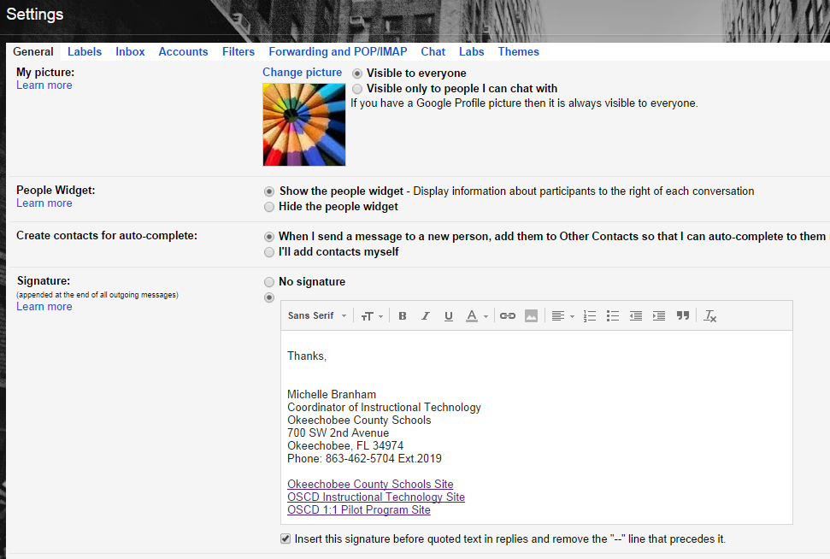
Step 4: Type your "Signature" in the text box. Signatures should include your name, school, grade level taught, and/or other information.
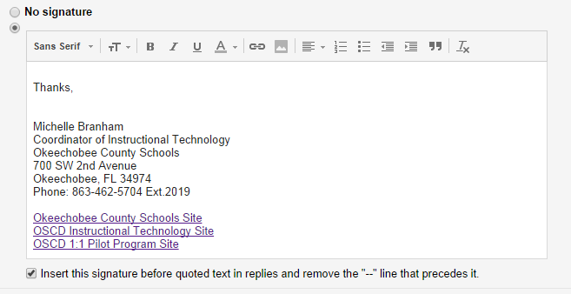
Step 5: Save your changes at the bottom of the page.
